Requirement List for Master Degree in Chinese Culture University
Ⅰ. Affiliation: Master Degree Program, Department of Political Science, College of Social Sciences
Ⅱ. Degree Conferred: Master Degree in Political Science
Ⅲ. Applied Academic Year: Applied to New Students Registered after 2018 Academic Year
(Approved by the Meeting on Academic Affairs on May 16, 2018)
Ⅳ. Minimal Credits Required for Graduation: 30 Credits
Ⅴ. The Accepted Number of Credits Taken Outside the Department (including in Taiwan and in Foreign Countries): 6 Credits (only the credits taken in the College of Social Sciences)
Ⅵ. Required Courses:
The Code Number of Course | Course Name | The Number of Credit Acquired | Course Hour | Remark
8351 | Seminar on Public Administration | 2 | 2 | Choose Any Two Courses from the Four
D011 | Seminar on International Politics | 2 | 2
K210 | Seminar in Political Philosophy | 2 | 2
K211 | Seminar on Comparative Politics | 2 | 2
 | 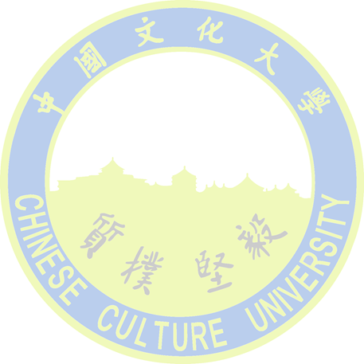  Total | 4 | 4

Ⅶ. Basic Course Requirements (Students who were accepted with equivalent academic capability or graduated with irrelevant majors must take extra courses from the basic courses listed below)
 | Course Name | The Number of Credit Acquired | Course Hour | Remark
1 | Research Methods for Political Science | 4 | 4
 | Total | 4 | 4

Ⅷ. Regulations for Applying Master Thesis Exam
1. Please follow “the Procedural Rule for Doctor and Master Degree Thesis Exam” promulgated by the University.
2. Other Regulations: Please follow “the Regulations to Acquire Master Degree” promulgated by the Department.
Ⅸ. Remarks

